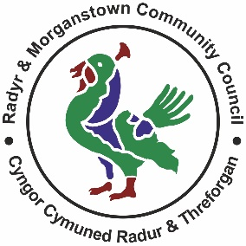
Radyr & Morganstown Community Council
Cyngor Cymuned Radur a Threforgan

Publicity and Communications Committee – Terms of Reference
The Publicity Group's Terms of Reference are as follows:
1. To ensure that the community served by Radyr and Morganstown Community
Council is kept informed about the Council's work - and other issues that may affect
the community.
2. To maintain editorial control over the Council's website's content and structure. To
maintain editorial control of the Council's Twitter feed and any other social media
outlets used by the Council (such as Facebook and Instagram).
3. To draft news stories, reports, feature articles and similar material drawing attention
to the Council's work - and other issues that may affect the community.
4. To commission and edit, as necessary, publicity material from other Council
Members (which can include news stories, reports, feature articles and similar
material).
5. Apart from items which simply inform the public about things that are happening in
Radyr and Morganstown (such as roadworks, festivals, MS or MP surgeries, or
opening and closing of businesses) - the Committee must ensure that items which
can normally be considered to represent the Council's views about specific issues
(such as planning applications or road safety) represent those views accurately.

6. To ensure that the Council is able to respond quickly and appropriately to developing
stories or issues, if need be. To do so in liaison with other Council members and/or
the Council's Clerk as appropriate.
7. To use our website and social media outlets - along with other outlets (such as the
Radyr Chain and other websites) to facilitate the Council's communication with the
public.
8. To keep the Council's website and social media outlets fresh, with new stories
published as often as possible to generate and maintain interest and understanding
of the Council's work. The Twitter & Social Media passwords to be held by the Clerk,
Assistant Clerk and Chair of the Committee.
9. The Chair of the Committee plus one other Committee member and the Clerk may
publish news items directly to the Council's website and social media outlets but
should consult the other Members of the Committee (48 hours’ notice) before
publishing any significant items which contain opinions or policy implications to seek
their views with regard to style, accuracy and content.
10. The Committee will seek to ensure that material published by the Council is clear,
concise, accurate, interesting and professionally written.
11. Any material published can be edited or removed, if the other members of the Group
agree that it should be (whether or not that decision is prompted by other
Councillors).
12. The new @radyr Email accounts will be used as contact details for all Council
correspondence and Councillors will need to be disciplined into checking the e mail
accounts on a regular basis.
13. The Committee will consist of those Members appointed at Annual Council.
The Clerk will also attend meetings of the Group.
(note: reference to the Clerk includes the Assistant Clerk)

